

Software engineering

PollMe

SRS

Prepared by: Team 2

# Table of contents

# Introduction

## Executive Summary

PollMe is a website providing feedbacks to moderators or speakers by giving the audience or students a quick poll depending on the speaker’s questions or opinions. PollMe can be linked to any official or virtual education system. PollMe should be considered as an official feedback that everyone can get information by it. Also, PollMe can provide the researchers with all the material they need by fast and simple ways.

## Document Overview

This document introduces PollMe website. It introduces general description, technical description, development plan and operation plan.

## Abbreviations and Terminologies

|  |  |
| --- | --- |
| **PollMe** | **Website name** |

# System description

## Introduction

PollMe offers an easy way of interaction between a speaker and his audience. Through taking a poll, ask questions like MCQ and see the percentage of the audience that answered right, get questions from the audience and see them questions on the speaker's (mobile / laptop) so no one needs to rise his hand while the speaker is talking and ask the question in front of the audience (which may be annoying or embarrassing for some). Also, it allows the speaker to get feedback about the topic introduced through a positive or negative poll, which he can see how many people in the audience understand the topic well. PollMe can be used in lectures, conferences, events and any other activities that need a feedback from the audience. The audience doesn’t need to make accounts and password to give their feedback or participate in polls, while the admin (the lecturer or the speaker) only needs to make an account to see the results of the polls and questions he asked or received. Pollme provides only one main device to control the survey e.g. the speaker or the researcher and the other devices that are connected to the main device with local network through wi-fi of a router or built-in hotspot.

## Modules

### Data processing

In our audience management system, audience/spectators will be able to deliver questions to the lecturer or the speaker in an easier way instead of traditional way of raising hands.

### User Area

Our system is designed to give an instant feedback to the lecturer or speaker from the audience/spectators without needing them to raise their hands and count them. The system shows the lecturer the exact number of audiences. When the speaker starts a poll, or asks a multiple choices question or a true or false question every one of the audiences get to answer in their audience interface, then, exactly the absolute number of the audience for each choice/answer.

### Admin area

## Users

There will be two types of users that will use our Audience Management System:

The speaker or the one that introduces or explains a topic or an idea. For example, the lecturer in the university or a speaker in a conference. This type will use the program by putting questions to the audience that are prepared before the lecture or the conference, written in a certain way in order to know how much the audience understands the topic. And Questions that come to the lecturer’s mind during a lecture or a conference, written instantly so that he could ask the audience.

The audience for example a student in university or audience in a conference. This type will use the program by answering the questions provided by the speaker or lecturer. Also, by giving a feedback on how much they understand the content of the topic. The audience also uses the program by writing the questions they want to ask or by asking for another Explanation from the lecturer and also by asking for the needed breaks.

# System Users

## User description

Each type of user has a different activity:

A) The user who wants to make a poll for his audience. He can submit the MCQs and see the total number of participants in his poll and the percentage of each answer choice on True or False questions. This type of user can also receive feedback from his audience as notifications while giving his lecture or conference. Here, the user is required to sign up on Pollme to make an account.

B) The second type of user is for those who take part of the poll with their opinions. They submit their answers, ask questions for the speaker, leave a feedback. They are not allowed to read other feedback messages from other users and aren’t required to enter a username and password.

## user description

# System Modules

## data processing

traditional way of raising hands. We will design a box that can fit up to 100 characters that enables the audience to write the questions they want to ask or ask for more explanation from the lecturer. Audience can also ask for breaks and leave a feedback

## User Area

We care about the privacy of the information that speaker has on his page, so we locked his data that he only can get accessed to it. Only the admin has a password to enter while the audience can submit their answers without entering usernames and passwords.

## Admin area

# System Functions

## Module functions

### Module function:

#### Description:

#### Input:

#### Output:

#### Pre-conditions:

#### Post-conditions:

### Module function:

#### Description:

#### Input:

#### Output:

#### Pre-conditions:

#### Post-conditions:

## Module functions

### Module function:

#### Description:

#### Input:

#### Output:

#### Pre-conditions:

#### Post-conditions:

### Module function:

#### Description:

#### Input:

#### Output:

#### Pre-conditions:

#### Post-conditions:

## Module functions

### Module function:

#### Description:

#### Input:

#### Output:

#### Pre-conditions:

#### Post-conditions:

### Module function:

#### Description:

#### Input:

#### Output:

#### Pre-conditions:

#### Post-conditions:

# System Models

## Use Case Diagrams :

This use case diagram shows the interaction between the lecturer and the admin interface.

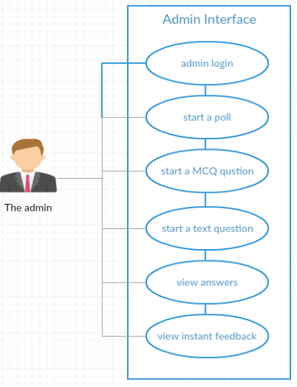

## System sequence diagram

This sequence diagram illustrates the processes that happen in the system between the admin, admin interface, client interface and the client.

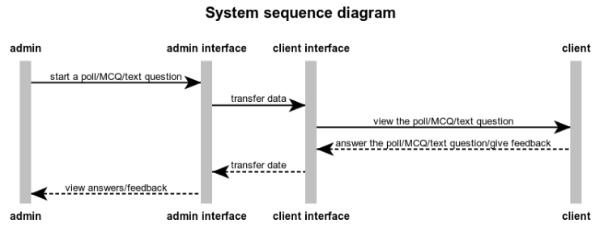

# Non-Functional Requirements:

## Security:

We care about the privacy of the information that speaker has on his page, so we locked his data that he only can get accessed to it. Only the admin has a password to enter while the audience can submit their answers without entering usernames and passwords.

## Usability:

Our web is usable, because you can vote for (presentation, lecture, etc...) if you understand the content, and you can vote if you don't understand it too, with better and easy ways like: true or false question and Mcq.

## Technology:

We will use:

HTML

CSS

JavaScript

PHP

## Delivery:

Prototype: 2/12/2018.

Final product: 2 weeks after final exams

# User Interfaces

* Client interface

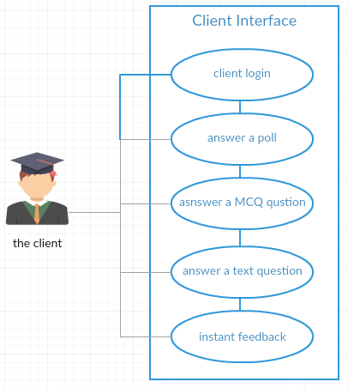

This use case diagram describes the interaction between the audience and the client interface.